**Review Worksheet: Homeostasis Intro and Thermoregulation**

**Name: ……………………………………………………………..**

*Do these questions, using your learning resources. Look at the “marks” to give you an idea of the level of detail required in the response (formative only – does not count towards your grade). At the end, mark your work, correct it, and fill in the reflection section. Questions marked * require you to use reasoning, inferring and application of knowledge, or perhaps extra research to get the answer. It won’t be right there in the text.*

*.*

1: Define homeostasis

(2 marks)

*…………………………………………………………………………………………………………………….*

*…………………………………………………………………………………………………………………….*

*…………………………………………………………………………………………………………………….*

*…………………………………………………………………………………………………………………….*

2: Why is it important to maintain a body temperature around 37oC?

(2 marks)

*…………………………………………………………………………………………………………………….*

*…………………………………………………………………………………………………………………….*

*…………………………………………………………………………………………………………………….*

*…………………………………………………………………………………………………………………….*

3: Why are homeostatic mechanisms important?

(2 marks)

*…………………………………………………………………………………………………………………….*

*…………………………………………………………………………………………………………………….*

*…………………………………………………………………………………………………………………….*

*…………………………………………………………………………………………………………………….*

4: What is “dynamic equilibrium”?

(2 marks)

*…………………………………………………………………………………………………………………….*

*…………………………………………………………………………………………………………………….*

*…………………………………………………………………………………………………………………….*

*…………………………………………………………………………………………………………………….*

5: What are tolerance limits?

(2 marks)

*…………………………………………………………………………………………………………………….*

*…………………………………………………………………………………………………………………….*

*…………………………………………………………………………………………………………………….*

*…………………………………………………………………………………………………………………….*

6: What is thermoregulation?

(3 marks)

*…………………………………………………………………………………………………………………….*

*…………………………………………………………………………………………………………………….*

*…………………………………………………………………………………………………………………….*

*…………………………………………………………………………………………………………………….*

*…………………………………………………………………………………………………………………….*

*…………………………………………………………………………………………………………………….*

7: Describe some ways in which the body can gain heat from the external environment.

(3 marks)

*…………………………………………………………………………………………………………………….*

*…………………………………………………………………………………………………………………….*

*…………………………………………………………………………………………………………………….*

*…………………………………………………………………………………………………………………….*

*…………………………………………………………………………………………………………………….*

*…………………………………………………………………………………………………………………….*

8: Describe some ways that the body can lose heat to the external environment.

(2 marks)

*…………………………………………………………………………………………………………………….*

*…………………………………………………………………………………………………………………….*

*…………………………………………………………………………………………………………………….*

*…………………………………………………………………………………………………………………….*

9: Describe how the body can gain heat via internal processes:

(3 marks)

*…………………………………………………………………………………………………………………….*

*…………………………………………………………………………………………………………………….*

*…………………………………………………………………………………………………………………….*

*…………………………………………………………………………………………………………………….*

*…………………………………………………………………………………………………………………….*

*…………………………………………………………………………………………………………………….*

10: What are thermoreceptors and where are they located?

(11 marks)

*…………………………………………………………………………………………………………………….*

*…………………………………………………………………………………………………………………….*

*…………………………………………………………………………………………………………………….*

*…………………………………………………………………………………………………………………….*

*…………………………………………………………………………………………………………………….*

*…………………………………………………………………………………………………………………….*

*…………………………………………………………………………………………………………………….*

*…………………………………………………………………………………………………………………….*

*…………………………………………………………………………………………………………………….*

*…………………………………………………………………………………………………………………….*

*…………………………………………………………………………………………………………………….*

*…………………………………………………………………………………………………………………….*

*…………………………………………………………………………………………………………………….*

*…………………………………………………………………………………………………………………….*

*…………………………………………………………………………………………………………………….*

*…………………………………………………………………………………………………………………….*

*…………………………………………………………………………………………………………………….*

*…………………………………………………………………………………………………………………….*

11: Use your notes to develop homeostatic feedback loops (similar to the example given) for the following: (8 marks + 10 marks)

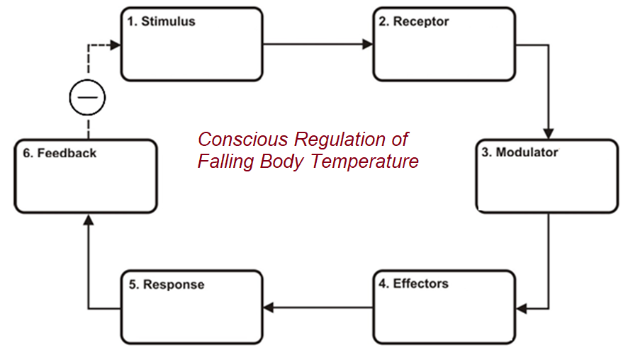

(8 marks)

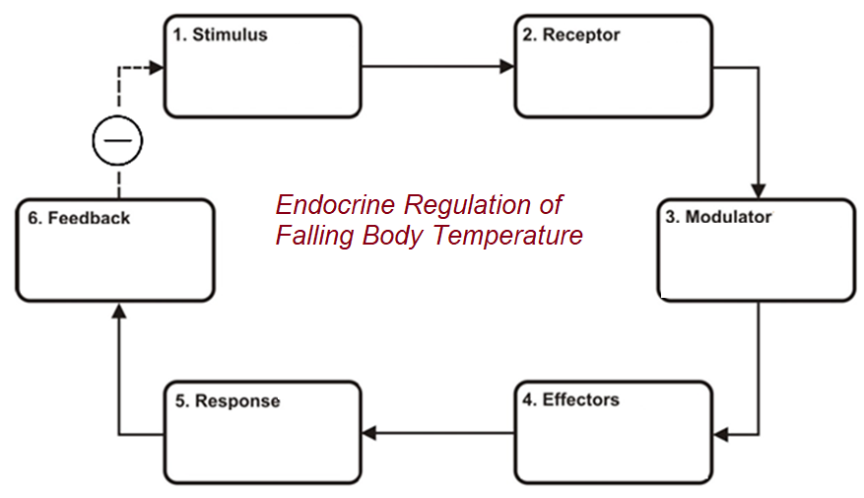

Go back and mark your work using the marking key provided. What score did you get? /50

*I included enough detail in my answers.*



*I was able to find information in the text/powerpoint presentation.*

*I was able to reason and infer where the information wasn’t directly in the text (questions with *).*

*I marked my work and wrote down any answers where I missed marks.*